EXPT NO:6 | OVER-PLOTTING REDUCTION TECHNIQUES
DATE: 09.02.2026 | OVER-PLOTTING REDUCTION TECHNIQUES

PRE-LAB QUESTIONS
- Why is over-plotting common in big data visualization?
Over-plotting occurs when many data points overlap in the same visual space. In big data, millions of observations share similar values, causing points to stack on top of each other and hide patterns.

- How does data density affect perception?
High data density makes it difficult for the human eye to distinguish individual points. Dense regions appear as solid blocks, leading to misinterpretation of trends, clusters, or outliers.

- What trade-offs exist between detail and clarity?
Showing raw data preserves detail but reduces clarity due to clutter. Simplifying or aggregating data improves clarity but may hide individual variations. Effective visualization balances both.

- How do AI datasets increase visualization complexity?
AI datasets are large, high-dimensional, and continuous. Visualizing such data increases overlap, making traditional scatter plots ineffective without over-plotting reduction techniques.

- Why is over-plotting a serious analytical risk?
Over-plotting can hide important patterns, exaggerate trends, or conceal anomalies, leading to incorrect analytical conclusions and poor decision-making.

OBJECTIVE : To apply techniques that reduce visual clutter in large-scale datasets.

SCENARIO A social media analytics company visualizes millions of user interactions to study engagement patterns.

IN-LAB TASKS (Using R Language) • Apply alpha blending • Implement jittering techniques • Use aggregation and binning

CODE:
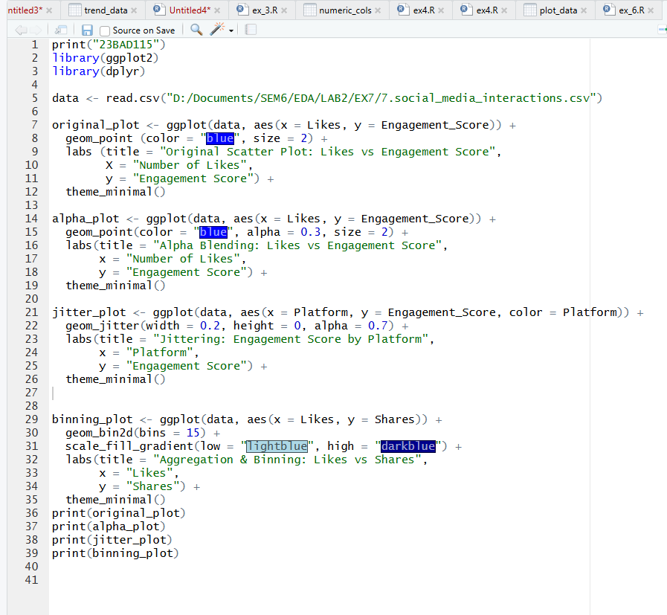

OUTPUT:

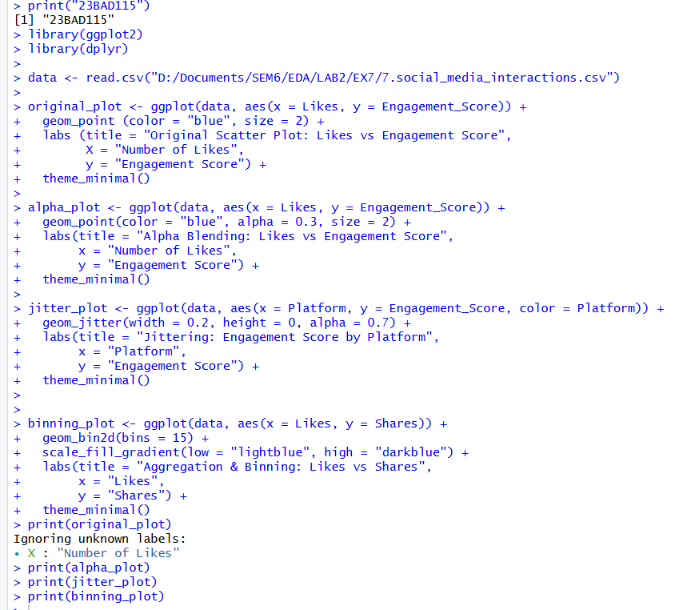

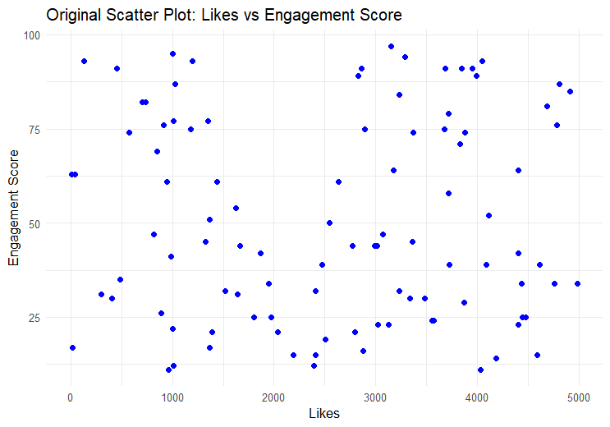
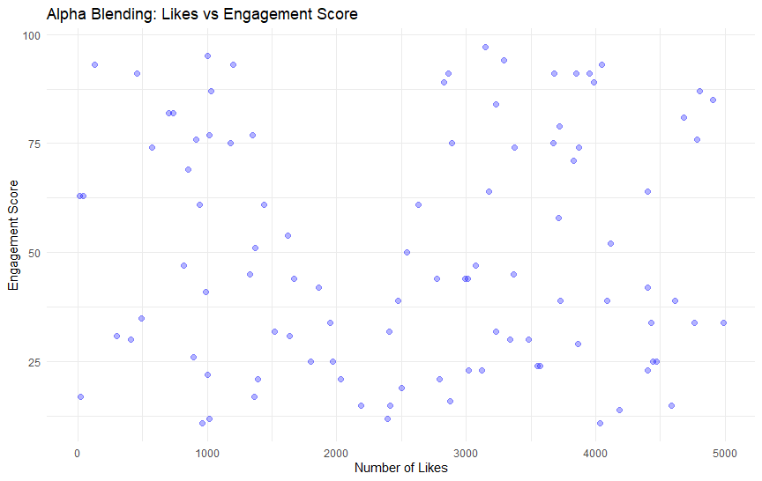

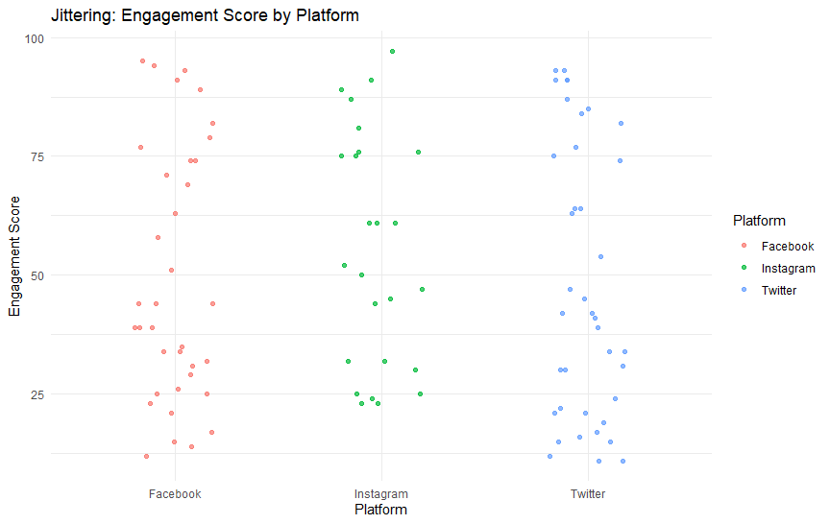

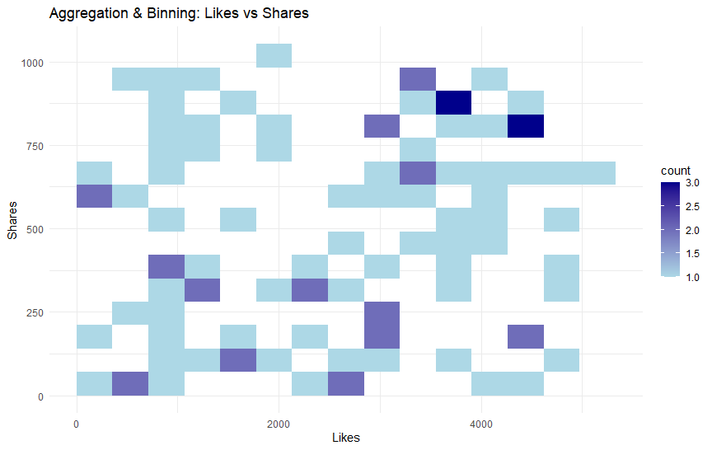

POST-LAB QUESTIONS
- Which technique provided the best clarity and why?
Aggregation and binning provided the best clarity because it groups large numbers of overlapping data points into bins and represents their density using color intensity. This removes visual clutter and makes overall engagement patterns between likes and shares easy to interpret, especially for large datasets.

- How does over-plotting distort analytical conclusions?
Over-plotting hides data density, overlaps important points, and masks clusters and outliers. This can lead to incorrect assumptions such as uniform distribution, weak correlation, or missing trends, ultimately resulting in misleading analytical conclusions.

- When should aggregation be preferred over raw plotting?
Aggregation should be preferred when working with large-scale datasets where individual points are less important than overall patterns, trends, or density. It is especially useful when raw plots become unreadable due to excessive overlap.

- How do these techniques support scalable AI analytics?
Over-plotting reduction techniques enable efficient visualization of massive AI datasets by summarizing information without losing key patterns. They help data scientists validate models, detect trends, and understand user behavior at scale, making analytics more interpretable and scalable.

- Explain real-world consequences of ignoring over-plotting.
Ignoring over-plotting can lead to poor business decisions, incorrect marketing strategies, biased AI models, and faulty predictions. In real-world systems like social media analytics, this may result in misunderstanding user engagement and ineffective resource allocation.

LEARNING OUTCOME: Students master over-plotting reduction for big data visual analytics.
ASSESSMENT
Description | Max Marks | Marks Awarded
Pre Lab Exercise | 5
In Lab Exercise | 10
Post Lab Exercise | 5
Viva | 10
Total | 30
Faculty Signature

